# CS 499 Module One Assignment Template

Austin Thompson

September 7th, 2025

Complete this template by replacing the bracketed text with the relevant information.

1. **Self-Introduction:** Address all of the following questions to introduce yourself.
   1. How long have you been in the Computer Science program?

I originally started out of high school in 2019 in the Computer Science program at Appalachian State University, I was there studying computer science for one and a half years. I ended up leaving there during covid and started working in the IT field for 3 years and then finally decided to come back and get my software engineering degree with SNHU which should be finished by December this year.

* 1. What have you learned while in the program? List three of the most important concepts or skills you have learned.
* While working and creating programs being able to break down the problems given or found during the code, and figuring out first what is causing it and then working through the areas I know to figure out how I can solve that problem is a great way to work through things.
* Being able to create and design project plans and planning the projected timeline for the project makes it easier for actual work and understanding what goes into creating something or working on something from scratch.
* Another skill would be understanding how different systems interact, with each other and different hardware. Things like databases and networks interacting with programs or the specific hardware they are designed for.
  1. Discuss the specific skills you aim to demonstrate through your enhancements to reach each of the course outcomes.

With this project I want to be able to show the ability to complete a project that was designed and planned out by myself. Being able to show the progress of design to completion, while being able to troubleshoot and get through all the issues that may arise during the project.

* 1. How do the specific skills you will demonstrate align with your career plans related to your degree?

For my career plans at this point I am not set on a direction so working on a project with different aspects could allow me to get a clearer idea of what direction I want to head in. Being able to prove to myself that I can create this project and showcase the skills I’ve worked on in class that I was guided in to be able to have the confidence going into the workforce.

* 1. How does this contribute to the specialization you are targeting for your career?

At this point in my learning, I want to try to lean towards working with databases, and the project is focused on interacting with the data in the database as the focal point of the project. Being able to create a database and write in a new language to interact with it will give me a more solid understanding of how you interact and maintain them.

1. **ePortfolio Set Up:**

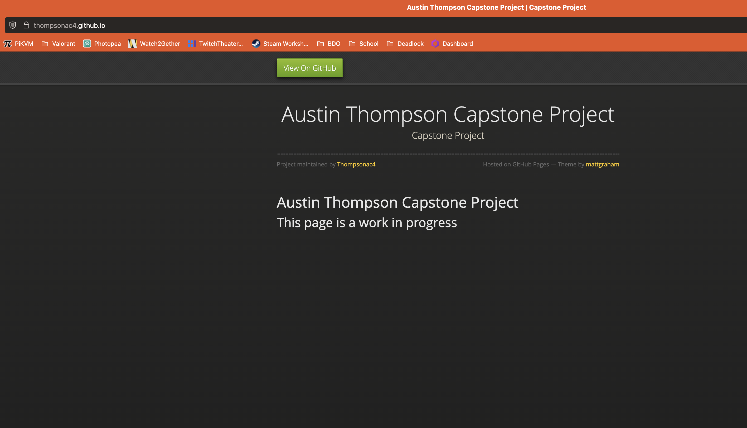

1. **Enhancement Plan:** 
   1. **Category One:** Software Engineering and Design
      1. **Select an** **artifact** that is **aligned with** **the** software engineering and design **category** and explain its origin. Submit a file containing the code for the artifact you choose with your enhancement plan.

The assignment I want to base this project on is the CS 340 project, this project used multiple parts for an animal shelter. The python file was used to handle CRUD, Create, Read, Update, and Delete interactions with the database. The database was a local mongoDB which had all the animal shelters data on the animals and their locations. Finally this was displayed for the user in a interactive python notebook in Jupyter notebook for showing off the data with a user interface for sorting searching and viewing the map and graph.

Note: Your artifact may be work from the following courses:

* IT 145: Foundation in Application Development
* CS 250: Software Development Lifecycle
* CS 260: Data Structures and Algorithms
* IT 315: Object Oriented Analysis and Design
* CS 320: Software Testing, Automation, and Quality Assurance
* CS 330: Computational Graphics and Visualization
* CS 340: Advanced Programming Concepts
* CS 350: Emerging Systems Architectures and Technologies
* CS 360: Mobile Architecture and Programming
* IT 365: Operating Environments
* IT 380: Cybersecurity and Information Assurance
* CS 405: Secure Coding
* CS 410: Reverse Software engineering
* IT 340: Network and Telecommunication Management
* IT 380: Cybersecurity and Information Assurance
  + 1. **Describe** a practical, well-illustrated **plan** for enhancement in alignment with the category, including a pseudocode or flowchart that illustrates the planned enhancement.

I want to recreate the C.R.U.D. system in C++ I also wish to change the data being shown to something I’m interested in making new data based on a game characters stats and abilities being able to showcase them and adjust them based on given values. I also want to use the C++ web framework to build a local webpage like the previous project to show and display the information in organized tables. I want an object oriented design with different classes handling the information, a character class, and database manager class to sort and organize this information.

Psuedocode:

class Character {

string name;

int wpnDMG, wpnFallOff, wpnScaling;

vector<string> abilities;

}

class DatabaseManager{

vector<Character> characters;

void addCharacter(Character c);

void updateCharacter(string name, Character c);

void deleteCharacter(string name);

character findCharacter(string name);

vector<Character> listAll();

}

MAIN:

Initialize DatabaseManager

Load exisiting data from DB

Serve local webpage with:

-table of characters

-potraits

-buttons for CRUD

-Charts for character stats

For this category of enhancement, consider improving a piece of software, transferring a project into a different language, reverse engineering a piece of software for a different operating system, or expanding a project’s complexity. These are just recommendations. Consider being creative and proposing an alternative enhancement to your instructor.

Think about what additions to include to complete the enhancement criteria in this category. Since one example option is to port to a new language, that is the kind of scale that is expected. This does not mean you need to port to a new language but instead have an equivalent scale of enhancement. Underlying expectations of any enhancement include fixing errors, debugging, and cleaning up comments, but these are not enhancements themselves.

* + 1. Explain how the planned enhancement will **demonstrate** specific **skills** and align with course outcomes.
       1. Identify and describe the specific skills you will demonstrate that align with the course outcome.

In this enhancement, I will demonstrate skills in modular software engineering and object oriented design by porting the project from Python to C++. I will apply clean design principles to separate data, logic, and presentation. By integrating a C++ web framework to create an interactive dashboard, I will showcase my ability for web development and user interface design.

* + - 1. Select one or more of the course outcomes below that your enhancement will align with.
* Design, Develop, and deliver professional-quality communication.
* Design and evaluate computing solutions that solve a given problem.

Course Outcomes:

1. Employ strategies for building collaborative environments that enable diverse audiences to support organizational decision-making in the field of computer science.
2. Design, develop, and deliver professional-quality oral, written, and visual communications that are coherent, technically sound, and appropriately adapted to specific audiences and contexts.
3. Design and evaluate computing solutions that solve a given problem using algorithmic principles and computer science practices and standards appropriate to its solution while managing the trade-offs involved in design choices.
4. Demonstrate an ability to use well-founded and innovative techniques, skills, and tools in computing practices for the purpose of implementing computer solutions that deliver value and accomplish industry-specific goals.
5. Develop a security mindset that anticipates adversarial exploits in software architecture and designs to expose potential vulnerabilities, mitigate design flaws, and ensure privacy and enhanced security of data and resources.
   1. **Category Two:** Algorithms and Data Structures
6. **Select an artifact** that is **aligned with the** algorithms and data structures **category** and explain its origin. Submit a file containing the code for the artifact you choose with your enhancement plan. You may choose work from the courses listed under Category One.

The enhancement I want to use in this case is a binary search tree BST that was shown in CS 300 for character lookup. Also implementing sorting algorithms for character ranking. This way I can have a clean sorting system and create an easy way to find the information I want to show.

1. **Describe** a practical, well-illustrated **plan** for enhancement in alignment with the category, including a pseudocode or flowchart that illustrates the planned enhancement.

**CLASS Node**

**STRING name**

**INTEGER wpnDMG**

**Node left**

**Node right**

**FUNCTION createNode(name, wpnDMG):**

**newNode = new Node**

**newNode.name = name**

**newNode.wpnDMG = wpnDMG**

**newNode.left = NULL**

**newNode.right = NULL**

**RETURN newNode**

**FUNCTION insert(root, name, wpnDMG):**

**IF root == NULL;**

**RETURN createNode(name,wpnDMG)**

**IF name < root.name:**  
 **root.left = insert(root.left, name, wpnDMG)**

**ELSE IF name > root.name:**

**root.right = insert(root.right, name, wpnDMG)**

**ELSE:**

**root.wpnDMG = wpnDMG**

**RETURN root**

FUNCTION search (root, name):

IF root == NULL:

RETURN NULL

IF name == root.name:  
 RETURN root.wpnDMG

ELSE IF name < root.name:

RETURN search(root.left, name)

ELSE:

RETURN search(root.right, name)

FUNCTION inorderTraversal(root):

IF root != NULL:  
 inorderTraversal(root.left)

PRINT(root.name, “ - Weapon DMG:”, root.wpnDMG)

inorderTraversal(root.right)

MAIN:  
 root = null

root = insert(from database)

PRINT “In order Listing if Characters:”

inOrderTraversal(root)

name = pageInput

dmg = search(root, name)

Print(name + “ Weapon Damage: ” + dmg)

For this category of enhancement, consider improving the efficiency of a project or expanding the complexity of the use of data structures and algorithms for your artifact. These are just recommendations. Consider being creative and proposing an alternative enhancement to your instructor. Note: You only need to choose one type of enhancement per category.

Think about what additions to include to complete the enhancement criteria in this category. Since one example option is to port to a new language, that is the kind of scale that is expected. Perhaps you might increase the efficiency and time complexity of an algorithm in an application and detail the logic of the increased time complexity. Remember, you do not need to port to a new language but instead have an equivalent scale of enhancement. Underlying expectations of any enhancement include fixing errors, debugging, and cleaning up comments, but these are not enhancements themselves.

1. Explain how the planned enhancement will **demonstrate** specific **skills** and align with course outcomes.
   1. Identify and describe the specific skills you will demonstrate to align with the course outcome.

I will demonstrate skills in implementing efficient algortihms and applying advanced data structures in C++. By using a binary search tree or hash maps for fast lookups I can optimize how characters and their information are stored and retrieved. This will show my ability to apply algorithmic principles to solve the set problem and manage the tradeoffs with speed, memory, and useability.

* 1. Select one or more of the course outcomes listed under Category One that your enhancement will align with.
* Design and evaluate computing solutions using algorithmic principles.
* Demonstrate innovative techniques and tools for industry specific goals.
  1. **Category Three: Databases**
     1. **Select an artifact** that is **aligned with the** databases **category** and explain its origin. Submit a file containing the code for the artifact you choose with your enhancement plan. You may choose work from the courses listed under Category One.

**From CS340 also there was the mongoDB database which was used to store and query the animal shelter database.**

* + 1. **Describe** a practical, well-illustrated **plan** for enhancement in alignment with the category, including a pseudocode or flowchart that illustrates the planned enhancement.

For the enhancement plan I want to create a new database schema for storing the character stats, which will still use MongoDB, having separate role based access for users versus admins.

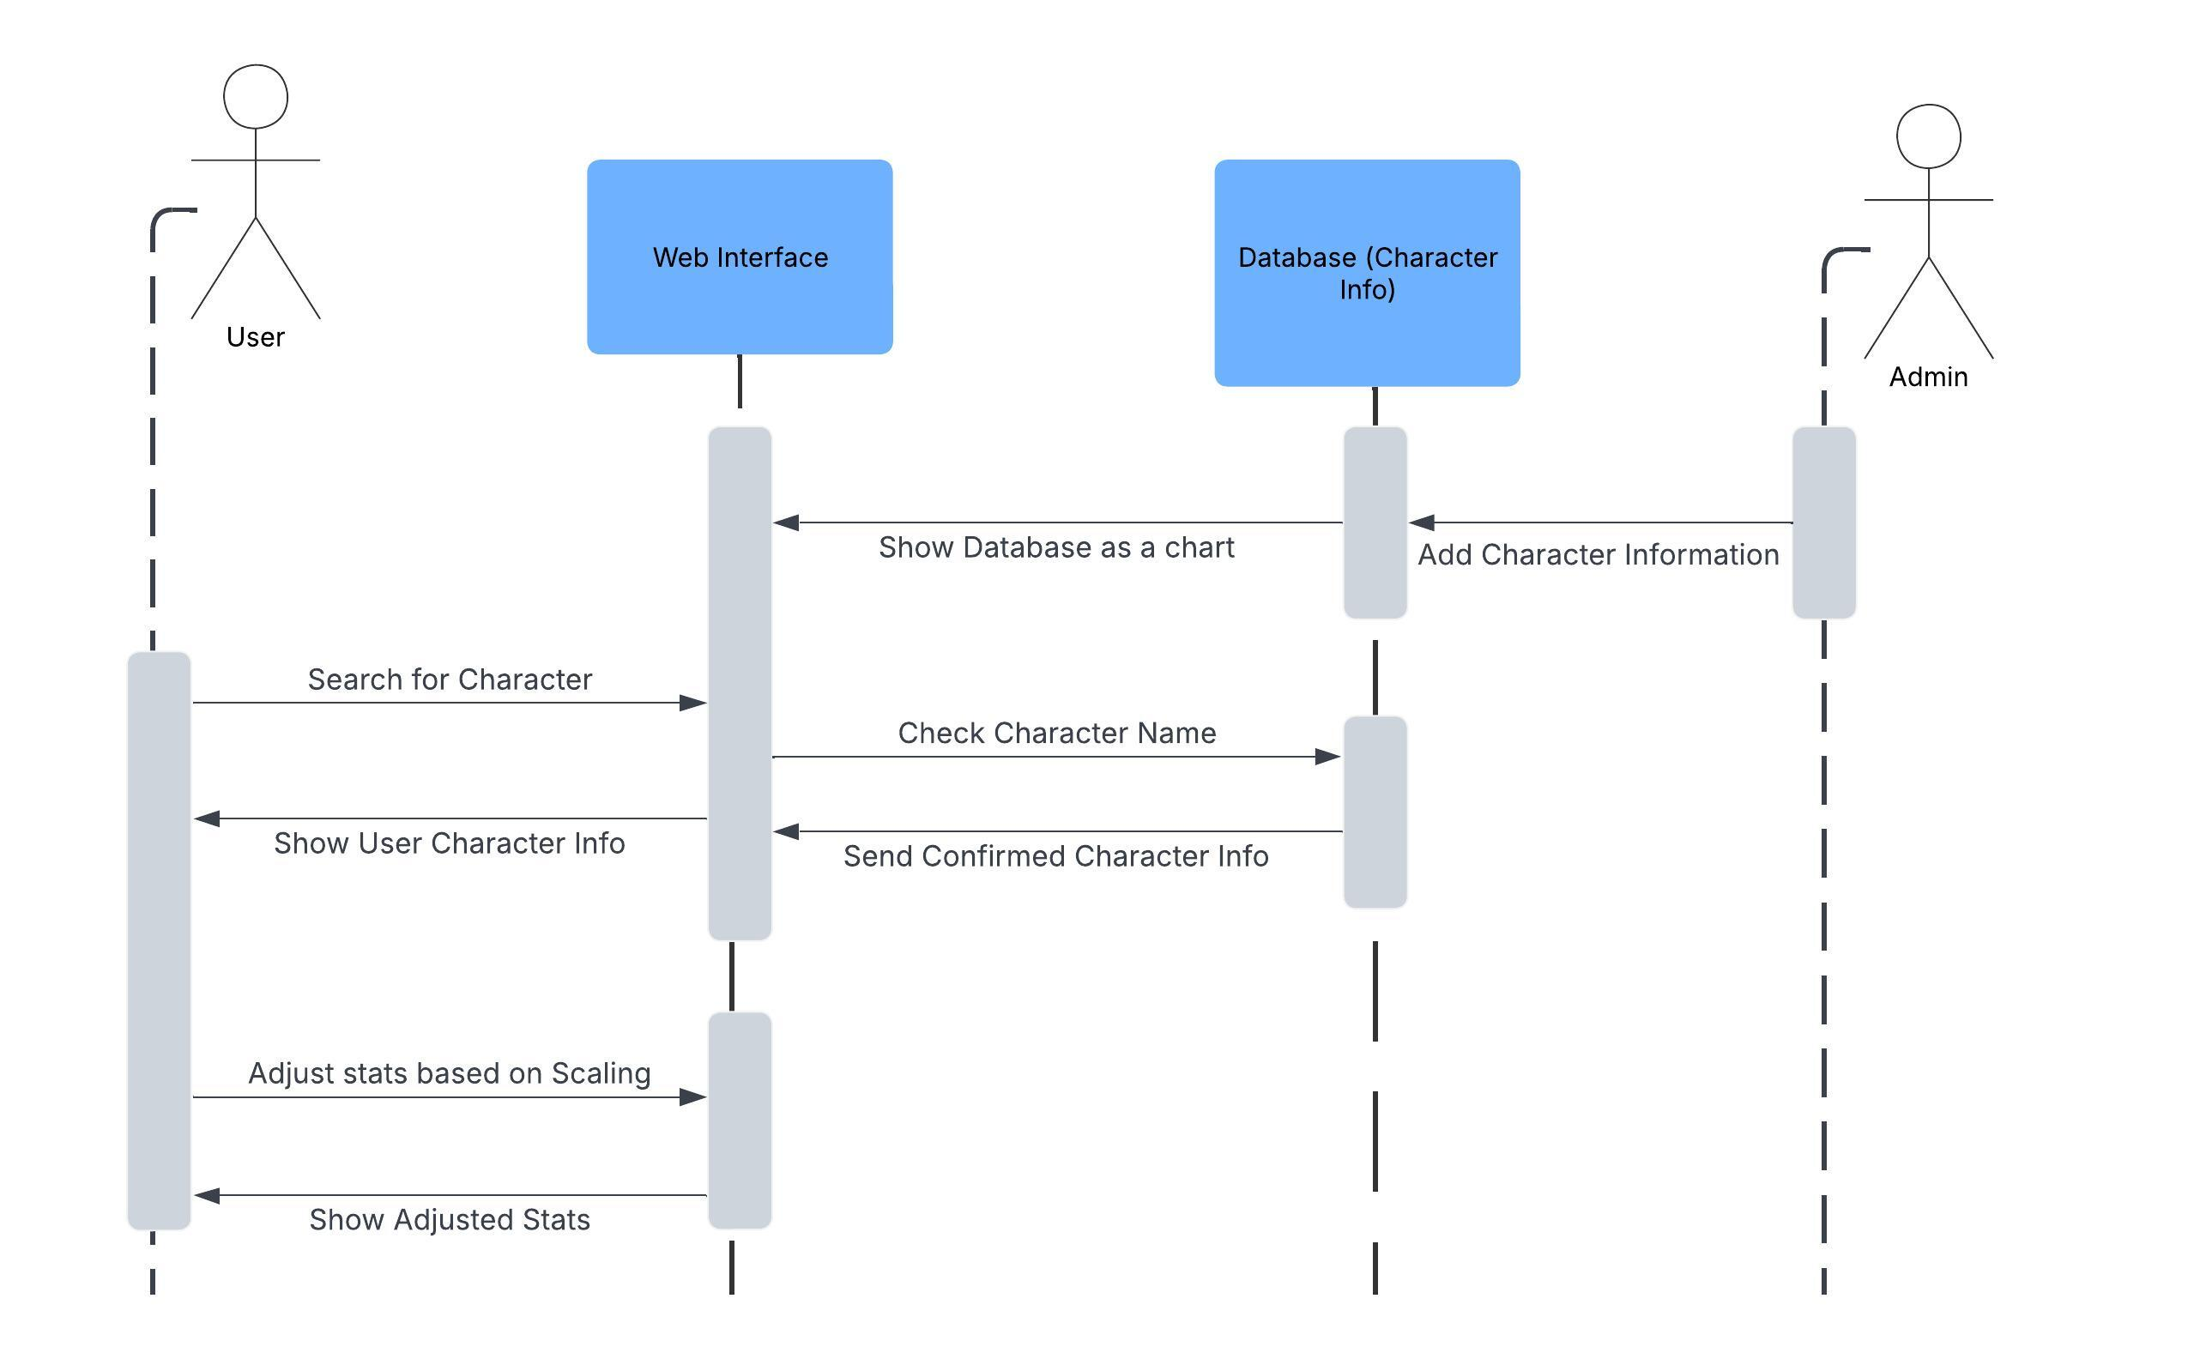

For this category of enhancement, consider adding more advanced concepts of MySQL, incorporating data mining, creating a MongoDB interface with HTML/JavaScript, or building a full stack with a different programming language for your artifact. These are just recommendations; consider being creative and proposing an alternative enhancement to your instructor. Note: You only need to choose one type of enhancement per category.

Think about what additions to include to complete the enhancement criteria in this category. Since one example option is to port to a new language, that is the kind of scale that is expected. Perhaps you might increase the efficiency and time complexity of an algorithm in an application and detail the logic of the increased time complexity. Remember, you do not need to port to a new language but instead have an equivalent scale of enhancement. Underlying expectations of any enhancement include fixing errors, debugging, and cleaning up comments, but these are not enhancements themselves.

* + 1. Explain how the planned enhancement will **demonstrate** specific **skills** and align with course outcomes.
       1. Identify and describe the specific skills you will demonstrate that align with the course outcome.

In this enhancement, I will demonstrate skills in designing and managing databases for complex and specific data. By creating a new schema for the game character and their stats, I can showcase relational design principles and normalization while also exploring flexible structures. I will implement secure CRUD operations in C++ with proper role-based access to protect data integrity, and integrate the database with a web dashboard for visualization.

* + - 1. Select one or more of the course outcomes listed under Category One that your enhancement will align with.
* Develop a security mindset that anticipates exploits and ensures privacy
* Employ strategies for collaborative, data driven decision making.

1. **ePortfolio Overall Skill Set**
   1. Accurately describe the **skill set** to be illustrated by the **ePortfolio** **overall**.
      1. Skills and outcomes planned to be illustrated in the code review

The code review will show my ability to design modular, object oriented solutions in C++. It will highlight the use of efficient data structures and algorithms, with secure CRUD operations, and integration with a web interface.

* + 1. Skills and outcomes planned to be illustrated in the narratives

The narratives will showcase my ability to connect technical enhancements to professional outcomes, explaining the rationale behind software design decisions and improvements. This will highlight skills ins software engineering, database management, and algorithmic problem solving. This will show that not only enhancements made, but also why they were significant from both a technical and professional standpoint.

* + 1. Skills and outcomes planned to be illustrated in the professional self-assessment

The professional self-assessment will show my ability to evaluate the growth I’ve made in computer science, reflecting on my previous coursework, projects, and enhancements to demonstrate readiness for industry roles. Showcasing my ability to critically assess strengths and areas for improvement while implementing my skills in real-world applications and goals.